**MONITORING LIGHT INTENSITY USING ANDROID**

**INTRODUCTION**

This work aims to use Arduino to sample the values of BH1750 at 10 Hz and transfer the data to an Android phone every second using HC06.

**ARDUINO**

Arduino is an open-source physical computing platform based on a simple i/o board and a development environment that implements the Processing/Wiring language. Arduino can be used to develop stand-alone interactive objects or can be connected to software on computer.

Arduino Uno is a microcontroller board based on the ATmega328P (datasheet). It has 14 digital input/output pins (of which 6 can be used as PWM outputs), 6 analog inputs, a 16 MHz quartz crystal, a USB connection, a power jack, an ICSP header and a reset button. It contains everything needed to support the microcontroller; simply connect it to a computer with a USB cable or power it with a AC-to-DC adapter or battery to get started. The specifications of the microcontroller board are listed in table1.

**Table 1. Arduino UNO specifications**

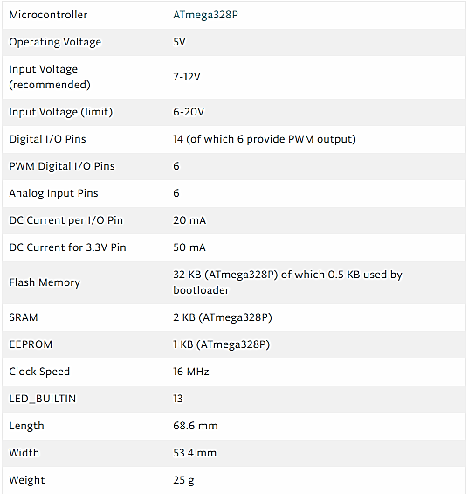

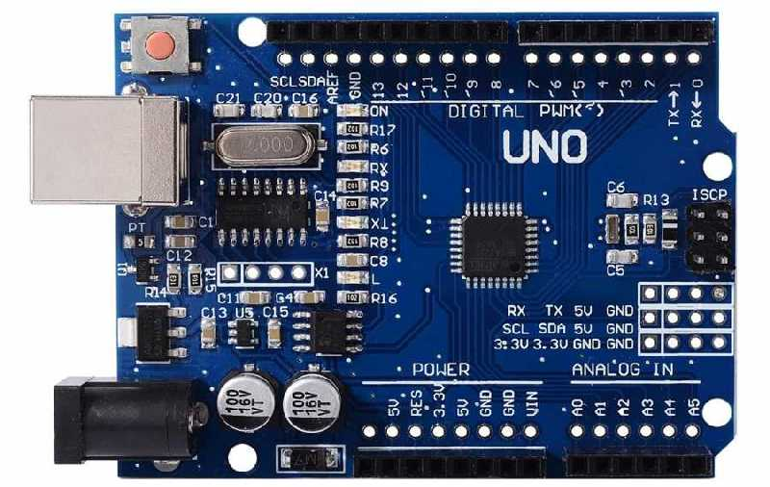

**Fig.1. Arduino UNO Microcontroller board**

**ANDROID**

Android is a mobile operating system developed by Google, based on the Linux kernel and designed primarily for touchscreen mobile devices such as smartphones and tablets. Android's user interface is mainly based on direct manipulation, using touch gestures that loosely correspond to real-world actions, such as swiping, tapping and pinching, to manipulate on-screen objects, along with a virtual keyboard for text input.

The Bluetooth terminal application is used for this task. The application provides control over any Micro-controller that uses a Bluetooth Module HC 05 or HC 06 through Android devices. This app can send and receive commands via Bluetooth so the developer can debug hardware problems easily.

The application can be downloaded from the google play store , https://play.google.com/store/apps/details?id=project.bluetoothterminal&hl=en.

**LIGHT INTENSITY SENSOR - BH1750**

The BH1750 ambient light intensity sensor breakout board has a 16-bit A2D converter built-in that can directly output a digital signal. The output from the sensor is in Lux (Lx) and does not require advanced calculations in the sketch. The BH1750 communicates using I2C Protocol, it is shown in Fig.2. The pin connections to Arduino microcontroller board is given in table2.

This sensor has 3 Measurement mode :

* H-resolution with Sensitivity 0.5 lux
* H-Resolution with Sensitivity 1 lux.
* L-Resolution with Sensitivity 4 lux

the datasheet recommended to use H-Resolution Mode due to kind of noise ( including in 50Hz / 60Hz noise) is rejected. And H-Resolution Mode is 1lx resolution so that it is suitable for darkness (less than 10 lx).

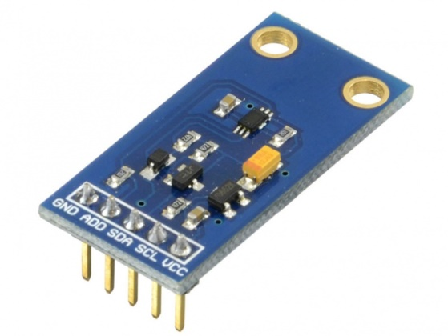

**Fig.2. BH1750 Light intensity sensor**

When objects which are lighted in homogeneous get the 1 lx luminous flux in one square meter ,their light intensity is 1lx. Sometimes to take good advantage of the illuminant, reflector can be added to the illuminant. So that there will be more luminous flux in some directions and it can increase the illumination of the target surface.

**Table 2. BH1750 to Arduino Pin connections**

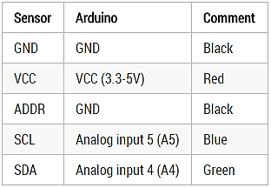

**BLUETOOTH MODULE – HC06**

The HC06 is a Serial port Bluetooth module which having fully qualified Bluetooth V2.0+EDR (Enhanced Data Rate) 3Mbps Modulation with complete 2.4GHz radio transceiver and baseband. It uses CSR Blue core 04‐External single chip Bluetooth system with CMOS technology and with AFH (Adaptive Frequency Hopping Feature). The Bluetooth module is shown in fig.3.

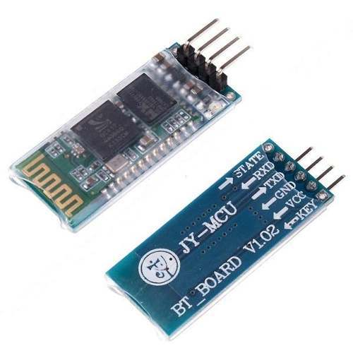

**Fig.3. HC06 Bluetooth Module.**

**Features of HC-06 Bluetooth Module :**

* Typical ‐80dBm sensitivity.
* Up to +4dBm RF transmits power.
* Low Power 1.8V Operation, 3.3 to 5 V I/O.
* PIO control.
* UART interface with programmable baud rate.
* With integrated antenna.
* With edge connector.
* Slave default Baud rate: 9600, Data bits:8, Stop bit:1,Parity:No parity
* Auto‐connect to the last device on power as default.
* Permit pairing device to connect as default.
* Auto‐pairing PINCODE:”1234” as default.
* Auto‐reconnect in 30 min when disconnected as a result of beyond the range of connection.

**SCHEMATIC**

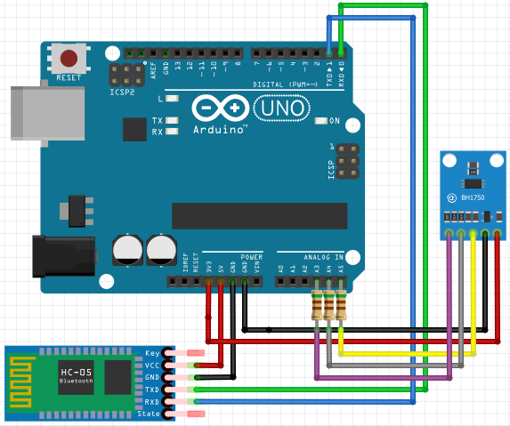

**Fig.4. Schematic of the circuit.**

**OUTPUT**

The Light intensity is measured and sent to Android device using HC06 module.

**ANDROID APP**

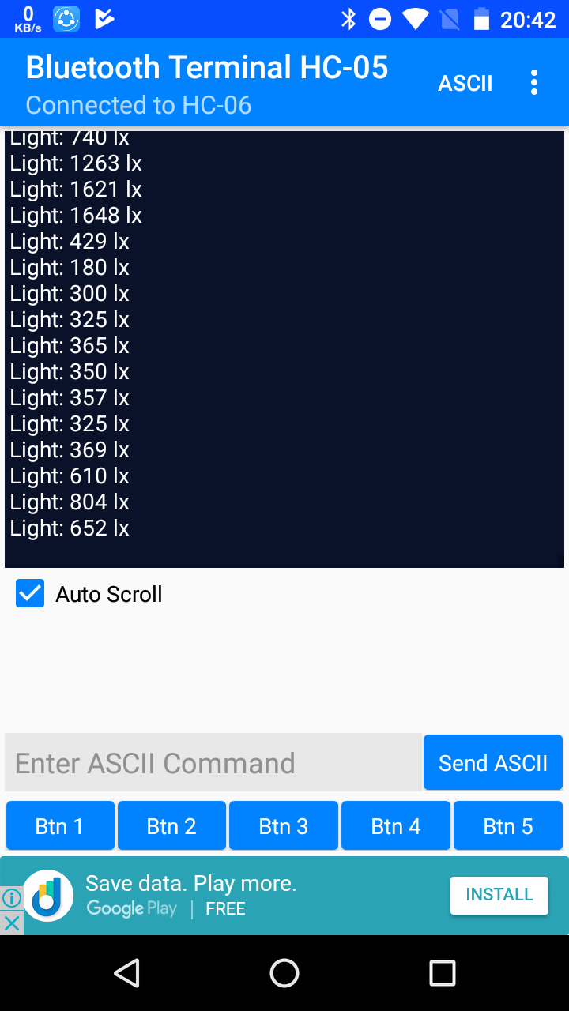

**Fig.5. Android App showing Light intensity values.**

**ARDUINO SERIAL MONITOR**

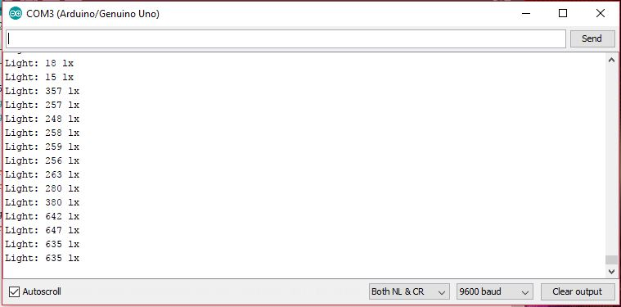

**Fig.6. Arduino serial monitor showing Light intensity values.**